1) Create s3 bucket and upload some objects to s3.

2) Deploy static website in s3 bucket.

3) Enable cross region replication on s3 buckets.

4) Configure bucket policy,only Admin user can see the objects of s3 bucket.

5) Setup lifecycle policies to automatically transition or delete objects based on specific criteria.

6) Push some objects in s3 using AWS CLI.

7) Write a bash script to create s3 bucket.

8) Upload one 1 gb of file to s3 using cli.

**1) Create s3 bucket and upload some objects to s3.**

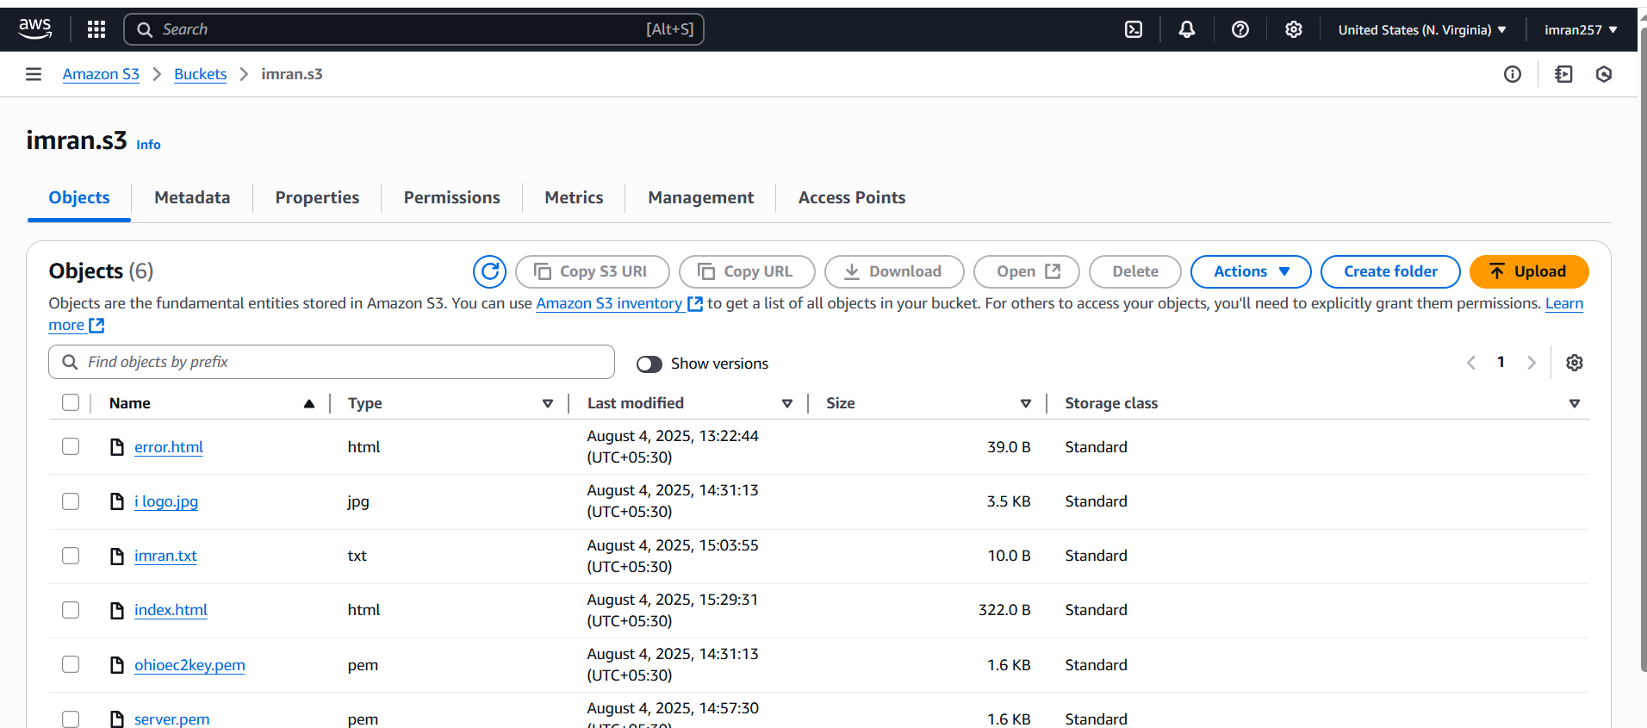

**2) Deploy static website in s3 bucket.**

[**https://s3.us-east-1.amazonaws.com/imran.s3/index.html**](https://s3.us-east-1.amazonaws.com/imran.s3/index.html)

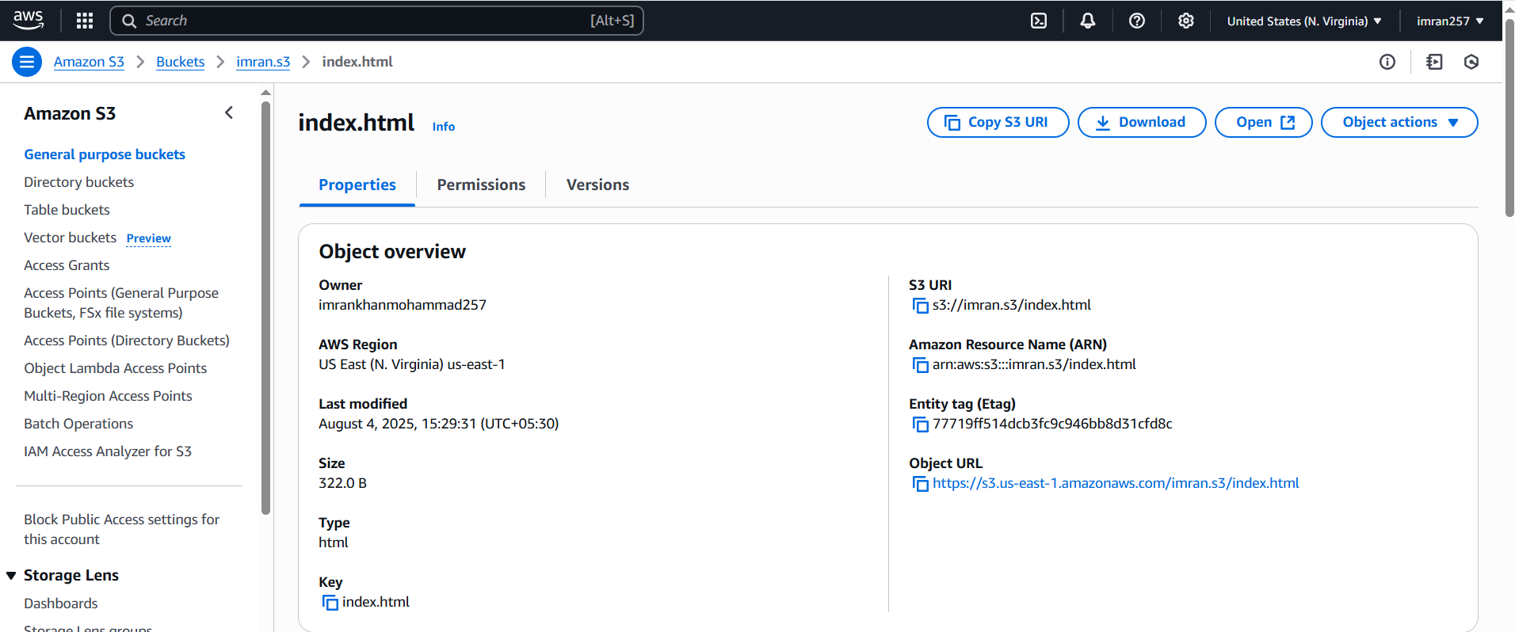

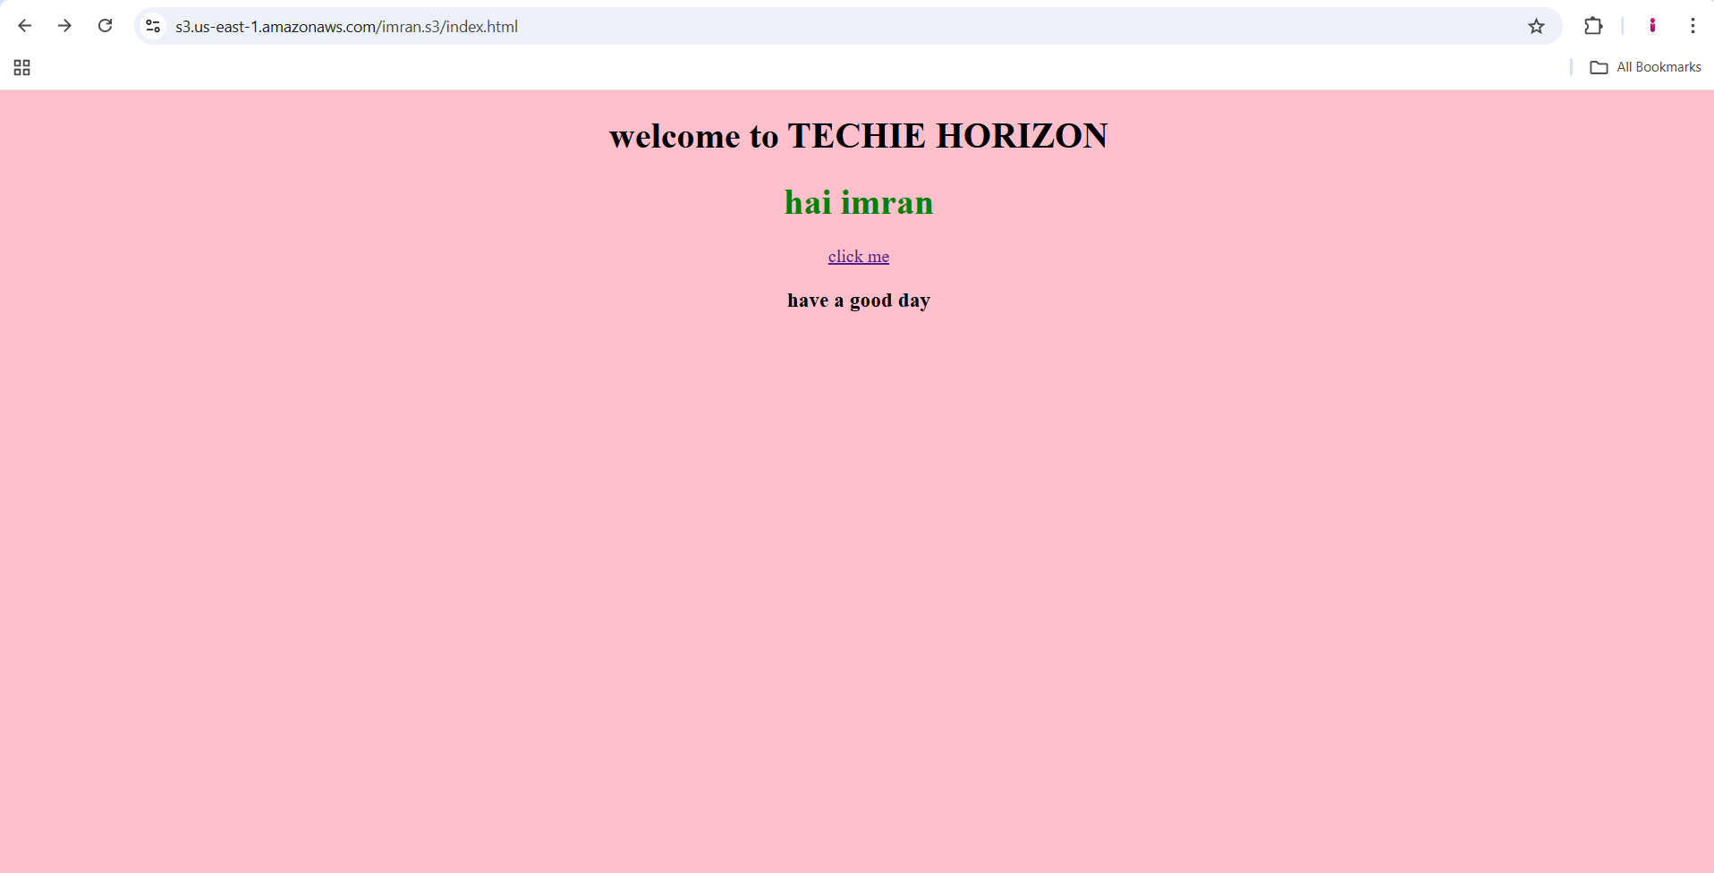

**3) Enable cross region replication on s3 buckets.**

**Step1 :Create two s3 buckets source and dest in diff. Region, with enable versioning on both S3**

**Step2 : Create Replication Rule in Source Bucket**

**Go to source bucket → Management tab → Replication rules**

**Click Create replication rule**

**Rule settings:**

**Name: replication-to-west**

**Status: Enabled**

**Scope: Leave as All objects (or filter by prefix/tag)**

**Destination:**

**Bucket: Choose your destination bucket from dropdown (in another region)**

**Permissions:**

**Select Create new IAM role (recommended)**

**AWS will automatically create a role with required permissions**

**Click Save**

**Step3: now upload a file in source s3 then open and check Replication status pending ,completed or fail and check in dest S3 is file showing or not.**

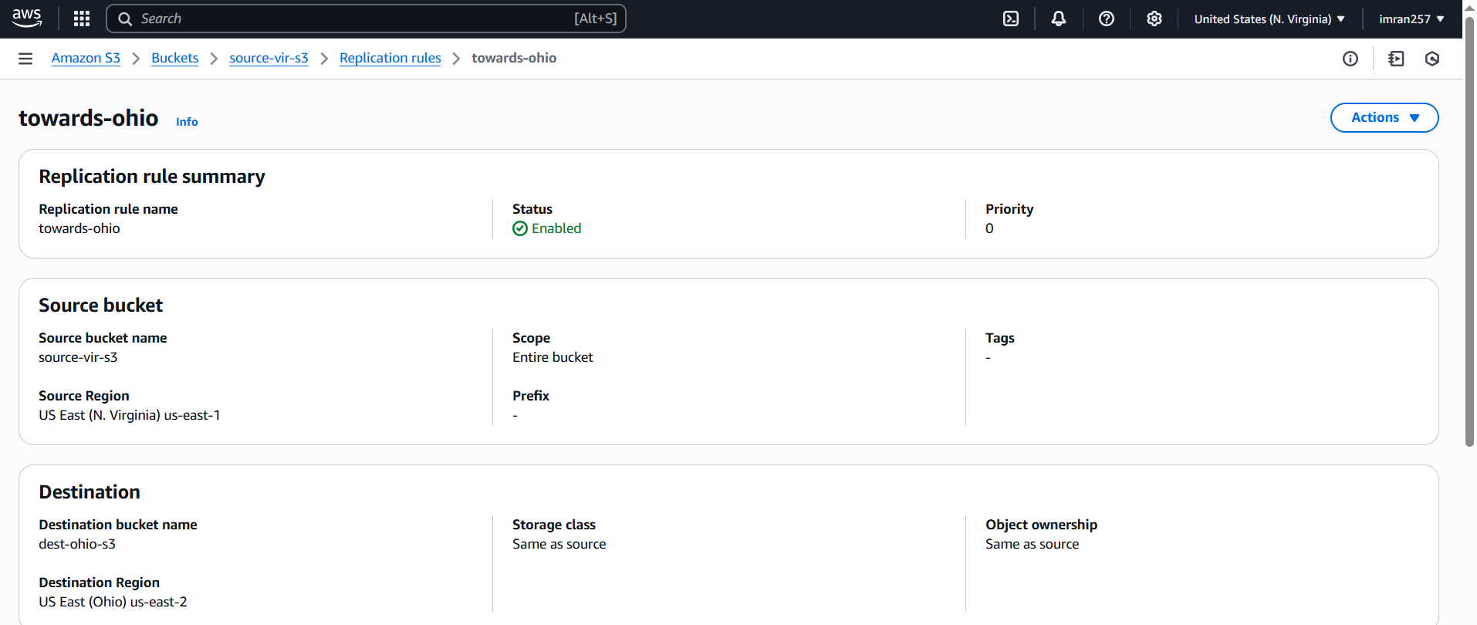

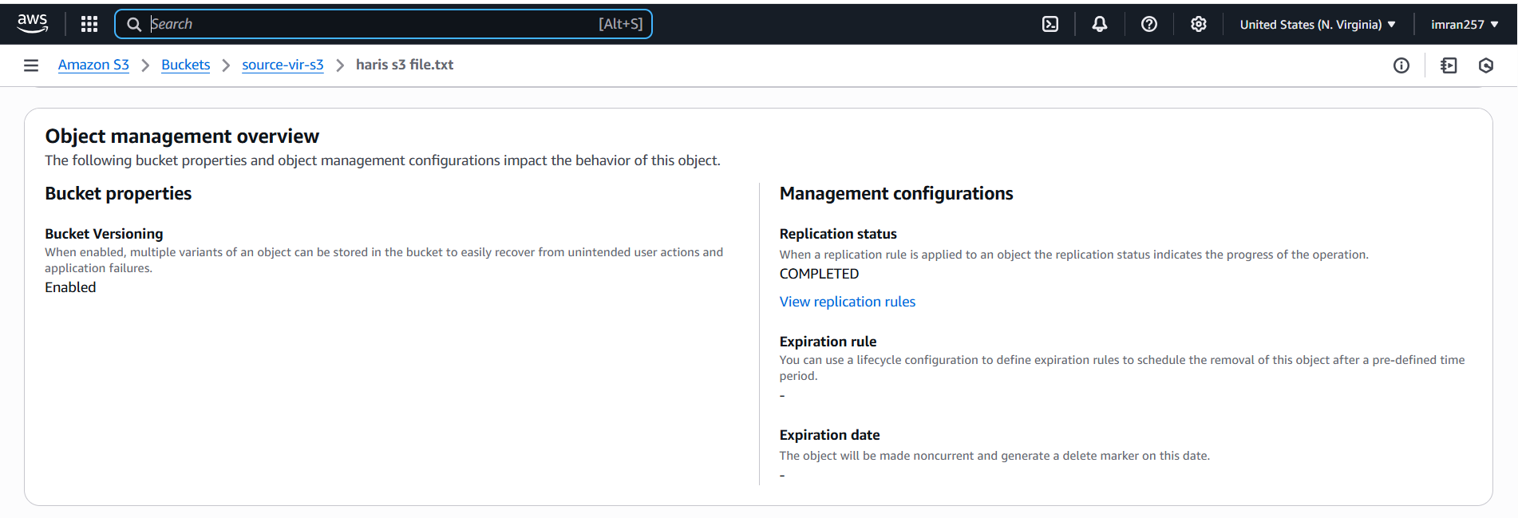

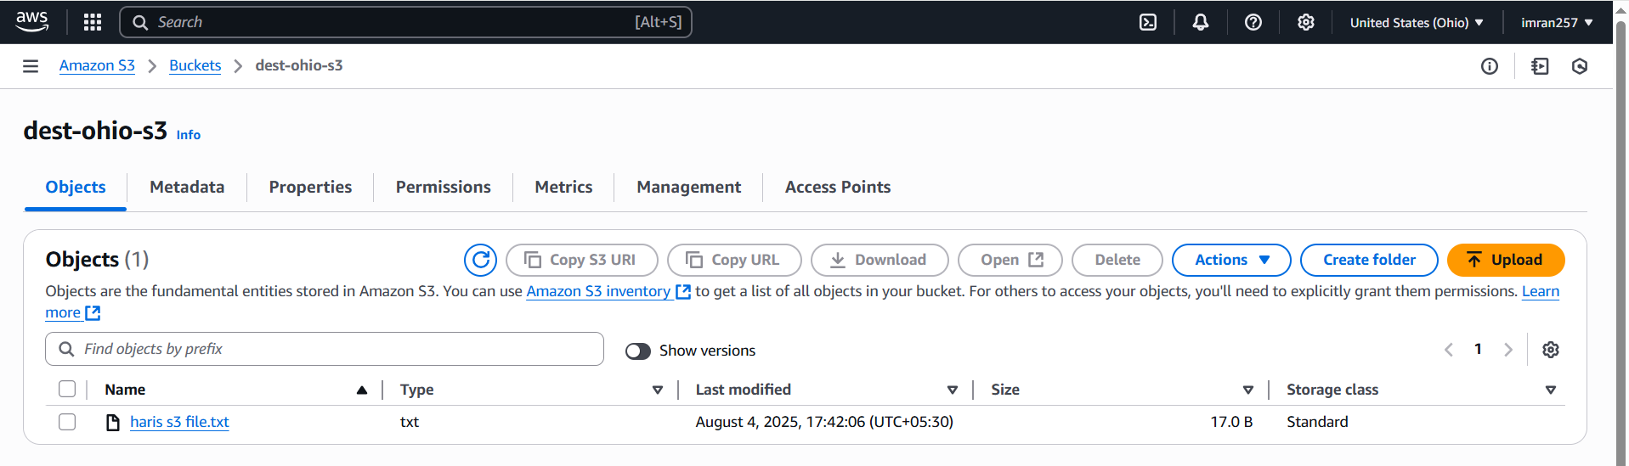

**—-----------------------------------------------------------**

**4) Configure bucket policy,only Admin user can see the objects of s3 bucket.**

**Go to your s3 and create permissions bucket policy,**

**{**

**"Version": "2012-10-17",**

**"Statement": [**

**{**

**"Sid": "DenyAllUsersExceptAdmin",**

**"Effect": "Deny",**

**"Principal": "*",**

**"Action": "s3:*",**

**"Resource": [**

**"arn:aws:s3:::source-vir-s3",**

**"arn:aws:s3:::source-vir-s3/*"**

**],**

**"Condition": {**

**"StringNotEquals": {**

**"aws:PrincipalArn": "arn:aws:iam::483591332684:user/Admin"**

**}**

**}**

**}**

**]**

**}**

**And save this policy.**

**User khan unable to open source-vir-s3 bucket even he has S3fullaccess.**

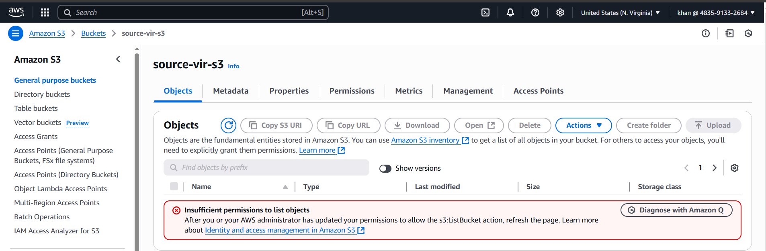

**User Admin have access.**

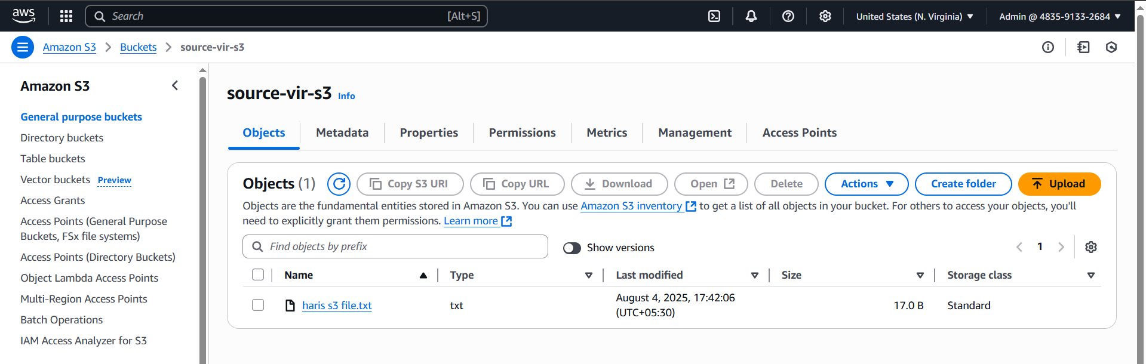

**5) Setup lifecycle policies to automatically transition or delete objects based on specific criteria.**

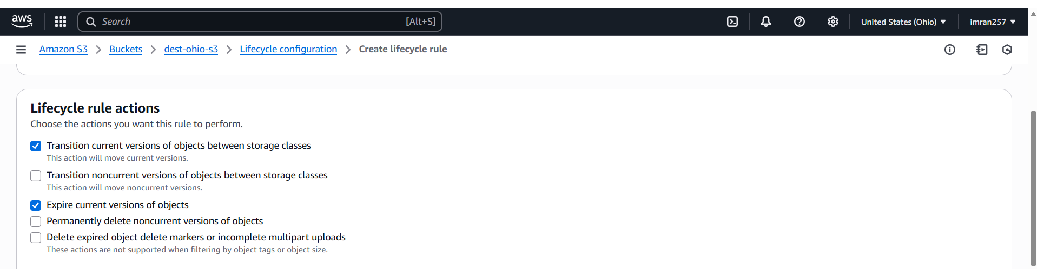

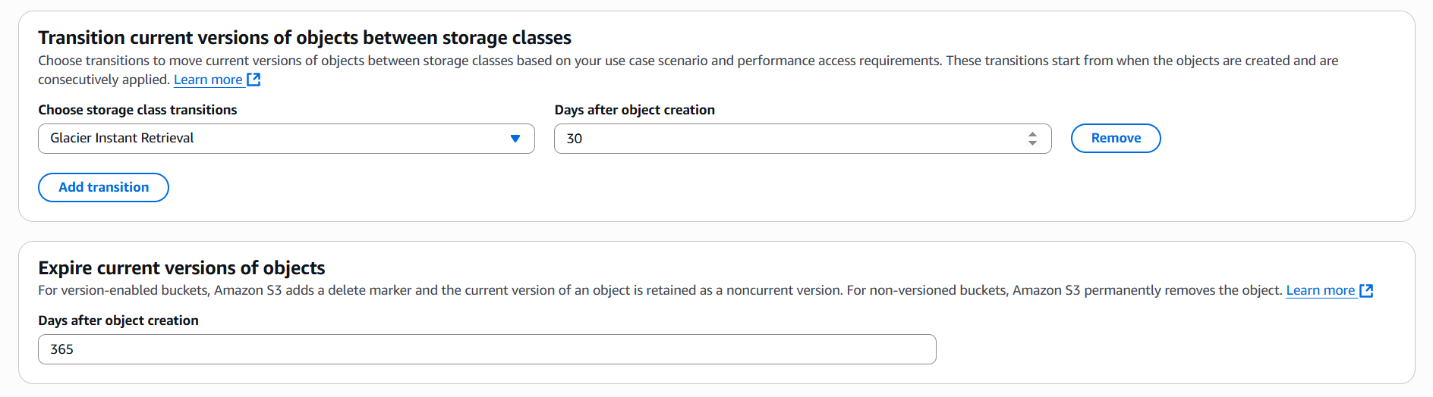

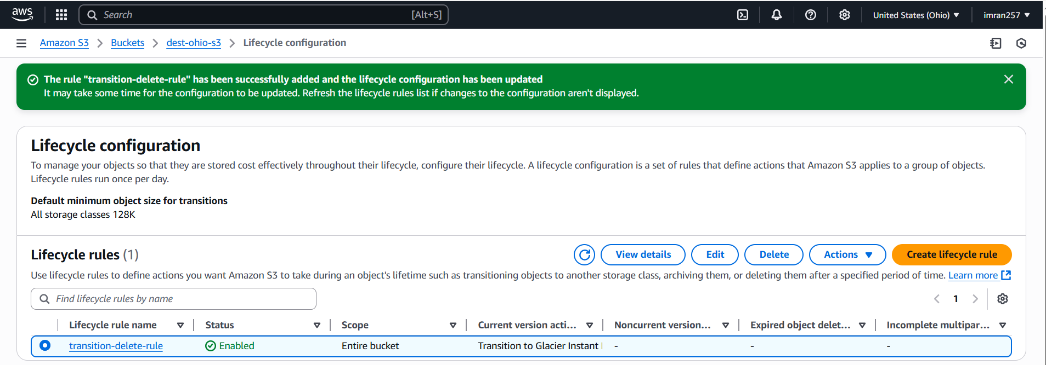

**6) Push some objects in s3 using AWS CLI.**

**Cmd: aws s3 cp file123.txt s3://dest-ohio-s3**

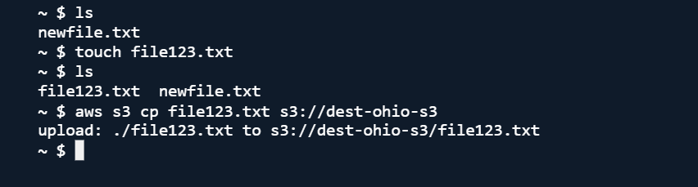

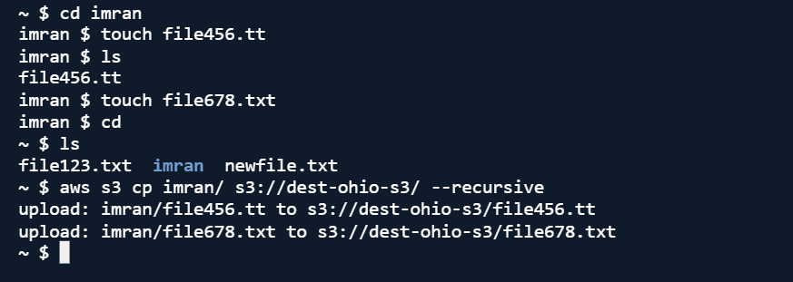

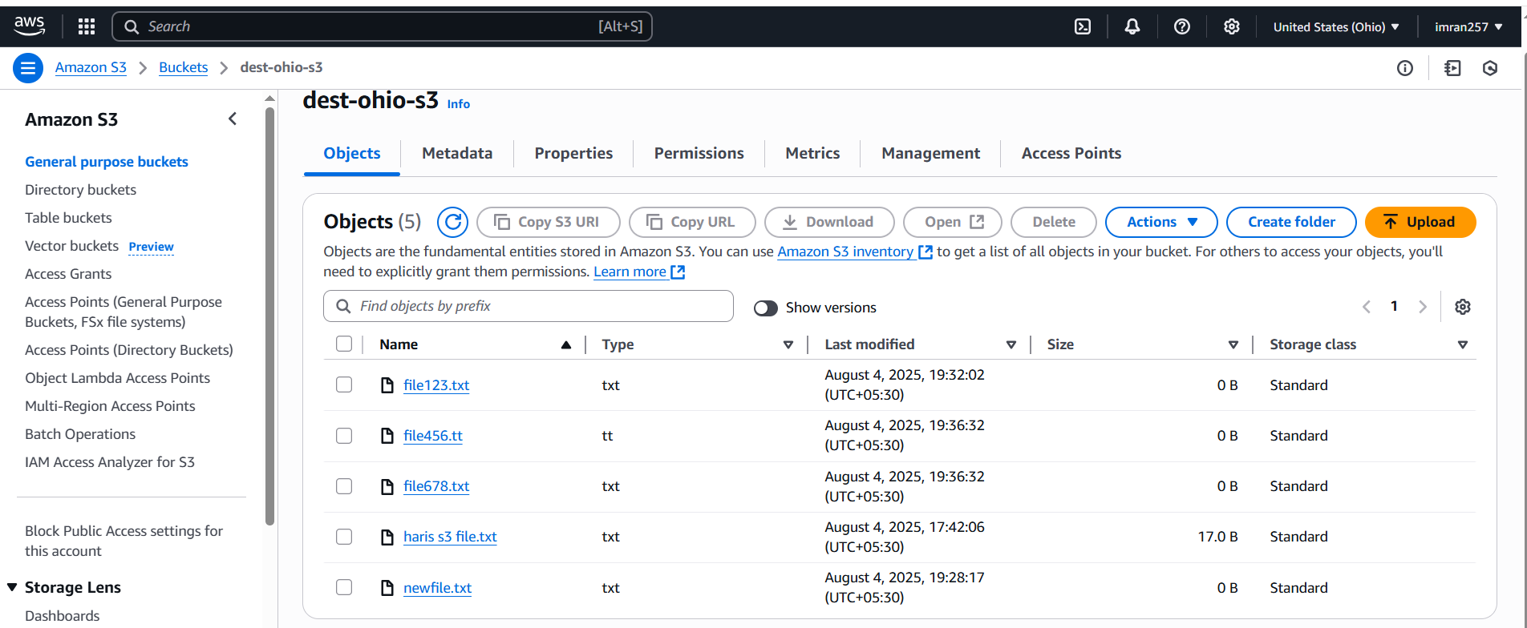

**7) Write a bash script to create s3 bucket.**

**Create s3.bash file.**

**#!/bin/bash**

**# Variables**

**BUCKET_NAME="imran257s3"**

**REGION="us-east-1"**

**# # Create bucket**

**aws s3api create-bucket --bucket "$BUCKET_NAME" --region "$REGION"**

**echo "S3 bucket '$BUCKET_NAME' created in region '$REGION'."**

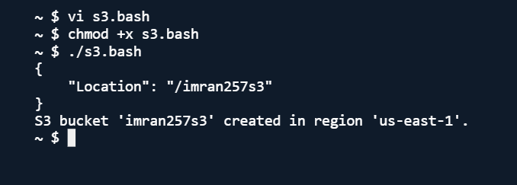

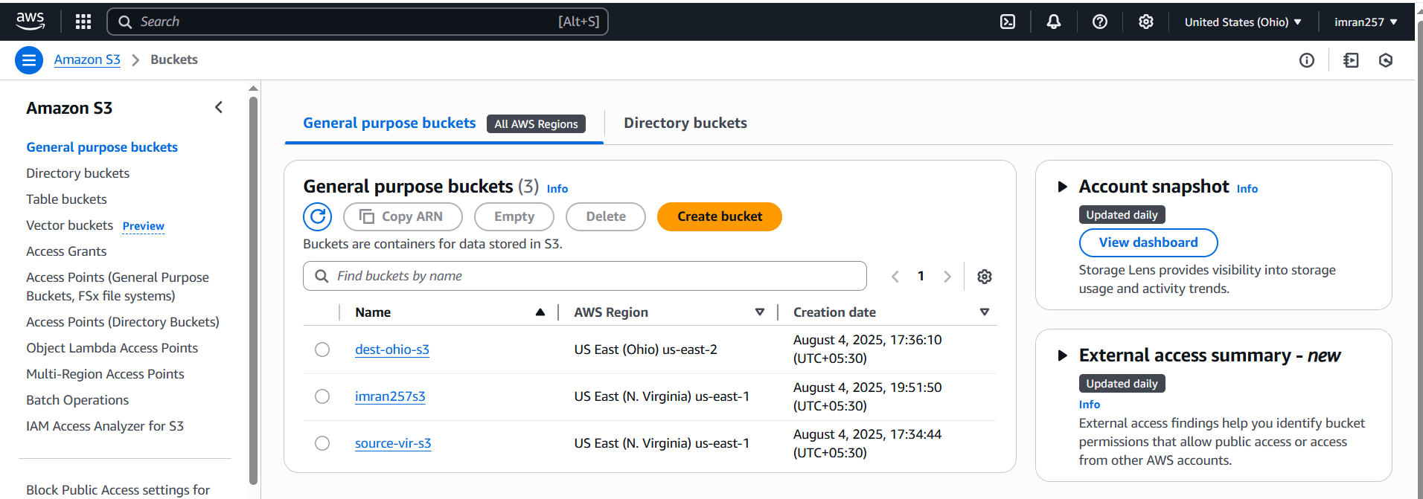

**8) Upload one 1 gb of file to s3 using cli.**

**After configuring aws in aws cli in windows,**

